How to Update Family Information in Infinite Campus
- Log into your Parent Portal account. If you do not know your username or password, please contact your Building Secretary for assistance.
- To change your address or phone number, click on the “More” button and then “Address Information”.
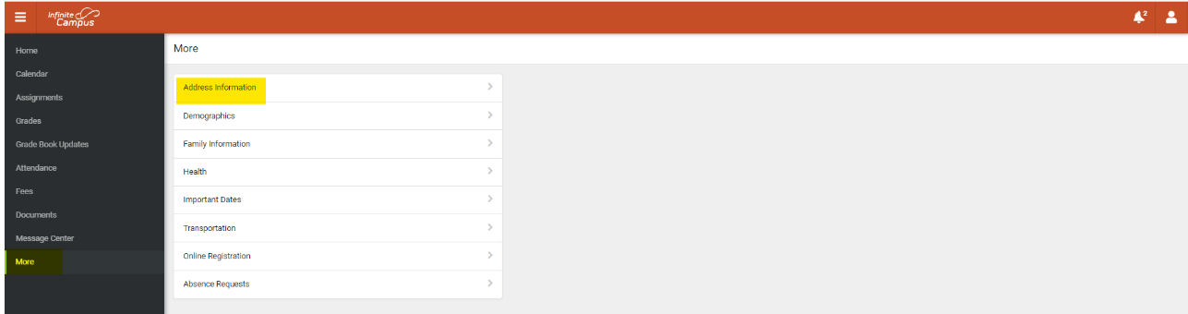
- Click on “Update” for the information that needs to be updated. Enter the updated information and click “Update” when completed.
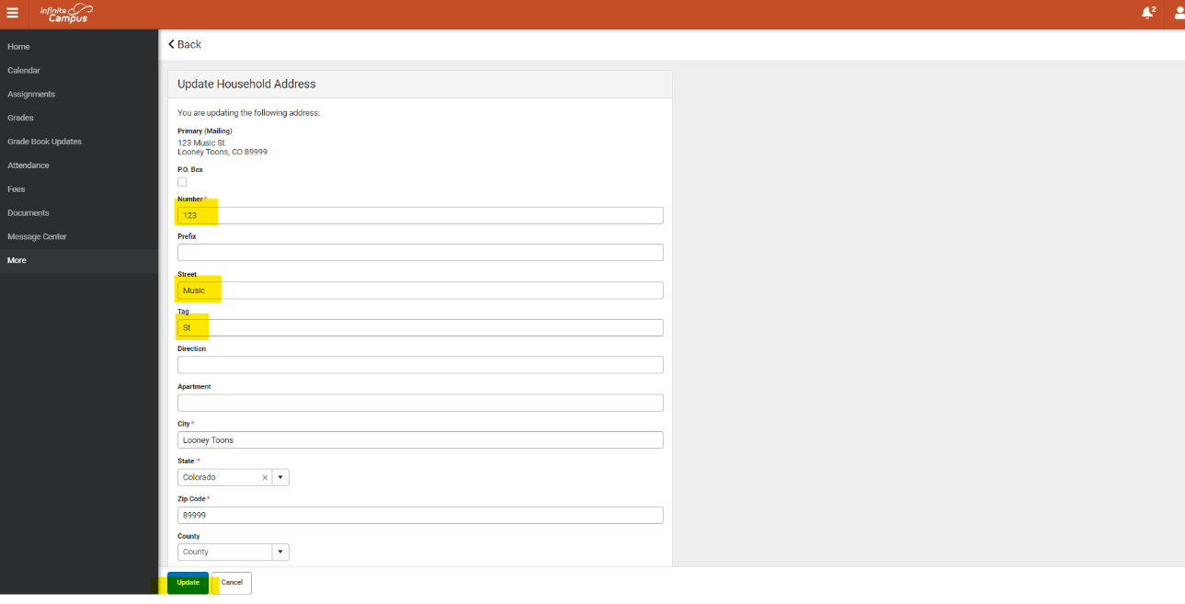
- To add Non-Household relationships, click on “Demographics”.
- To update phone numbers, emails, emergency priority, or relationships click on “Family Information”.
- Changes to information may take 3-5 business days to be processed. Please do not request the same change multiple times.

